Genetic Services at  ETSU Medical Genetics  (Partial List)  • Genetic evaluation/consultation by a  • board-certified clinical geneticist  • (pediatrics and adults)  • Diagnostic Genetic testing including  • Chromosome Microarray analysis and  • molecular studies  • Genetic counseling/recommendations  • for management, and regular follow-up  • of patients with genetic conditions  PEDIATRICS  • Multiple Congenital Anomalies  • Dysmorphic Features  • Intellectual Disability  • Behavioral Disorders/ADHD  • Autism Spectrum Disorder  • Abnormal Growth & Development  ADULTS  • Intellectual Disability  • Behavioral Disorders  • Family History of Inherited Disorders  • Short/Tall Stature  CANCER GENETICS  • Personal and/or Family History of Cancer:  • Breast, Ovarian, Colon Cancers, etc.  • Syndromic Cancers: Multiple Endocrine  • Neoplasia, Macrocephaly-Overgrowth  • Syndromes, etc.  PRENATAL GENETICS  • Pre-test and post-test counseling for:  • • Maternal serum screening  • • (AFP/Quad test)  • • Noninvasive Prenatal  • • Testing/Screening (NIPT/NIPS)  • • Invasive Prenatal Diagnosis  • • (Amniocentesis, CVS)  • Multiple Miscarriages/Infertility  • Personal and/or Family History of  • Inherited/Genetic Conditions | Our Team  MJ Hajianpour, MD, PhD, FACMGG  Stefanie Yoon, FNP-C  423-433-6848  Jennifer Carver, FNP-C  423-433-6848  Heather Marshall, LPN  423-433-6801  Amber Hall, LPN  423-433-6810  ETSU Medical genetics  325 N. State of Franklin Rd.  Johnson City, TN 37604 | ETSU Medical genetics  - Clinical Genetics  - Pediatrics & Adults
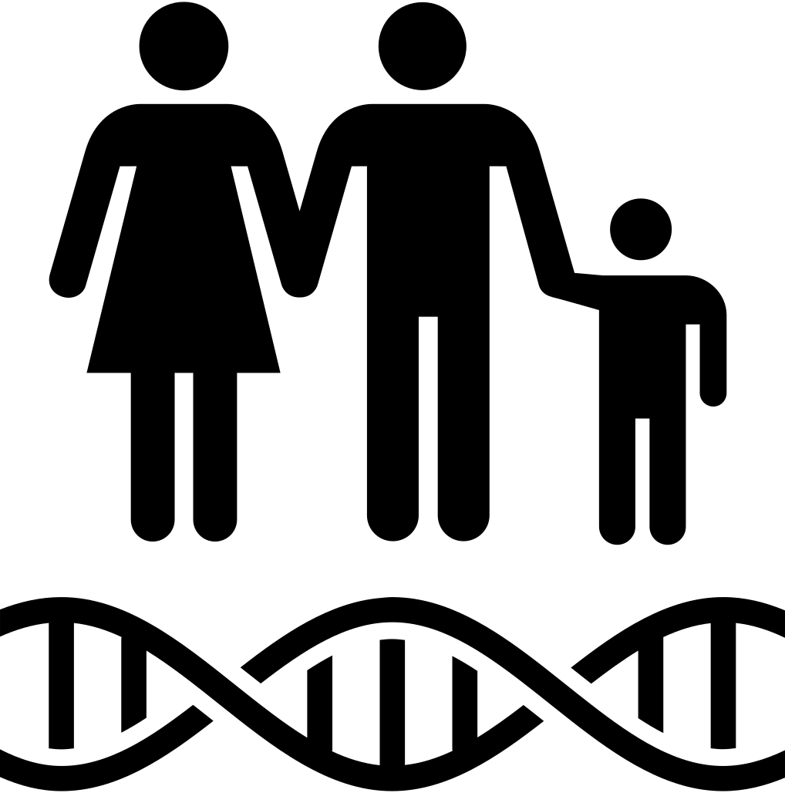  What is Clinical Genetic?  - Evaluation of babies/ infants/ Children and adults with birth defects/ multiple congenital anomalies, developmental delay, speech and language deficit, intellectual disability, and behavioral disorders (ADHD, Autism, etc.).  - Diagnosis of genetic disorders verified with genetic studies (if available).  - Identify at-risk relative for the known genetic condition in the family by analysis of family history/ Pedigree  - Provide genetic counseling including description of identified genetic disorder, mode of inheritance, and recurrence risk | Clinical Genetics Services  - Abnormal Newborn Screening (NBS): The ETSU Medical Genetics is a follow-up center for abnormal newborn screening tests which is a State program for diagnosis of certain genetic disorders/ inborn errors of metabolism in newborns.  - Clinical diagnosis of inherited disorders/ genetic disorders verified by specialized genetic testing including Chromosome Microarray (CMA), Gene Sequencing with deletion/ duplication analysis, Next Generation Sequencing (NGS), Whole Exome Sequencing (WES) and Whole Genome Sequencing (WGS).  - Carrier and pre-symptomatic testing: these tests are used to identify genetic changes when disorders are suspected after birth, or sometimes much later in life. Tests are useful to identify at-risk family members or asymptomatic carriers of the known gene alteration (mutation) in the family. | 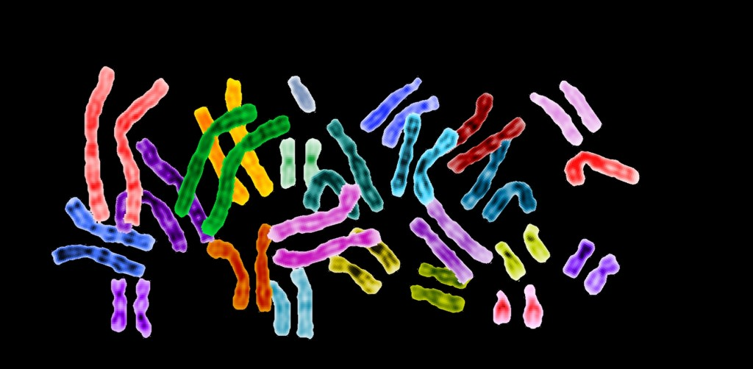  Our Process Involves:  - Review reason for the referral for genetic consultation.  - Mailing a package to the patient/ guardian to collect the medical and family history  - Pre-clinic review of the gestational history, present illness and past medical history  - Prepare and analyze a three-generation pedigree (family history)  - Schedule the patient for genetic evaluation and genetic testing  - Provide pre-test and post-test counseling  - Referring and coordinating patient care based on identified genetic condition including physical/ occupational/ speech therapies.  - Providing emotional support and connection to support groups  - Continued follow-up as needed throughout the lifespan

